Thank You!

To have a record of this mini reading: Please print this page or select 'file' / 'save as' to save it on your hard drive. When saving use (web page, complete) as the file type. If you have any problems or comments about using this feature, please contact Astrolabe.

Here is the Astro Chart you requested:

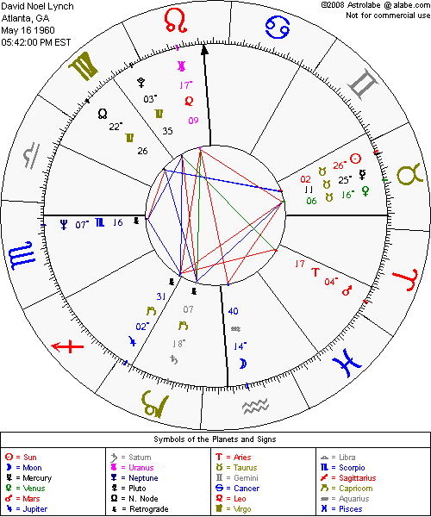
Hi there, here is the interpretation of the astrological chart that you asked for. Thank you for visiting our web site. This report has been created especially for you. It represents your Unique picture at the time you were born and at the place you were born. If you are unsure of the exact time of day of your birth (or the date or the place), the reading will probably not seem as accurate as it could be in certain places, but other parts will seem to be very appropriate. You will notice at certain places in the reading that contradictory information seems to be given. This is to be expected, because the personality of most people is extremely complex. For example, at times we are quite shy and at other times we are very aggressive, and so forth. You will also notice that, at certain points in the reading, certain patterns may be repeated over and over, especially in a longer more detailed report than this one. This is also to be expected. This simply means that your horoscope has an extremely strong focus on this particular pattern and that you should pay extra close attention to what is said about it. Now, on with your Report!
Name: David Noel Lynch
May 16 1960
5:42 PM Time Zone is EST
Atlanta, GA
Rising Sign is in 04 Degrees Scorpio
You tend to be quiet, reserved, secretive and, at times, quite difficult to understand. Others notice your deep emotions and feelings and wonder how to draw you out. Stubborn and tough, you fight for any position you believe in. You are very resourceful and formidable when you become angered or upset about something. You enjoy living life at the cutting edge -- for you life must be experienced intensely and totally. Quite courageous, you are willing to take calculated risks. Easily hurt by others, you often strike back with bitter sarcasm. Sensitive and curious, you are concerned with the deeper mysteries of human psychology. Once you have become interested in any subject, you pursue it with total fanaticism.
Sun is in 26 Degrees Taurus.
You are known for being patient, slow moving and careful -- you love to prolong and savor enjoyable times. You appreciate and need comfort, ease and warm surroundings. Be careful of a tendency to become placid and self-satisfied and to overeat (especially sweets). You require strenuous situations in order to grow and mature properly, even though you try to avoid them. Affectionate, even-tempered and slow to anger -- when you do become emotionally upset, you are also slow to forgive and time must pass before your calm returns. You demand real results from any situation -- abstractions are very difficult for you to comprehend. Very artistic, your hands love to mold and shape things. You portray an earthy, physical sexiness that others find quite seductive.
Moon is in 14 Degrees Aquarius.
Very freedom-oriented, you must always be able to do what you wish, no matter what. You become stubborn and recalcitrant when others try to force you into a mold. You are a true democrat -- you are not a follower, but you enjoy being with those who are like-minded. You appreciate emotional self-control -- you practice it yourself and you look for it in others. You solve problems, including emotional ones, with your brains and intellect, not your feelings. Try to be tolerant of those who have powerful and obvious emotional responses -- not everyone is as objective, cool, dispassionate and detached as you are.
Mercury is in 25 Degrees Taurus.
A slow and careful thinker, you like to present ideas visually and concretely. Abstractions are quite difficult for you to understand. For you, everything must be practical and useful in order to merit your attention. You are a perfectionist -- you enjoy being skillful enough to handle the dexterity required of fine craftsmanship. Cautious and conservative in your thinking, you are very slow to change your opinions. You are more apt to respond to an appeal to your feelings than to an appeal to logic or reason.
Venus is in 16 Degrees Taurus.
You are known to be a warm and affectionate person, and you tend to form long- lasting attachments. The reverse of this is that you can also be quite possessive once you have made a commitment. The beauty, luxury and comfort of your surroundings are important to you and you will devote much time and energy to making your home just right. Beware of your tendency toward self-indulgence, especially with respect to eating incorrectly. You also need outside stimuli to get you in gear When things come too easily for you, you can be lazy and indolent.
Mars is in 04 Degrees Aries.
You are very independent and self-assertive, and you have lots of physical energy. You are not satisfied unless you can be the first to do something. As such, you are more comfortable in leadership positions than you are as an underling. When you are challenged by anyone for anything, you delight in the competitive process and will fight long and hard for your beliefs. You are bold and courageous and often act without thinking. At times, in your zeal to get ahead, you are tactless and offensive -- learn that cooperation with others can often bring you nearer to your goals quicker because of the support you will get.
Jupiter is in 02 Degrees Capricorn.
You tend to feel that the only results that are worthwhile are the results that are concrete and demonstrable. You distrust abstract solutions and appreciate measurable achievements. An excellent organizer and planner, you are optimistic as well as practical and realistic about what can and what cannot happen. Very responsible, you consider it a personal weakness to be wrong about anything. This makes you appropriately cautious. You are very efficient but you tend to be cool and detached.
Saturn is in 18 Degrees Capricorn.
Very serious-minded and mature, you have the ability to take on responsibilities and to carry out important duties. You can also be trusted to be extremely practical and thrifty. A good organizer, you are the ideal one to be counted on to take a clearly defined project through to its logical conclusion. An achiever, you pride yourself on your ability to focus your attention totally on some worthy goal and then attain it.
Uranus is in 17 Degrees Leo.
You, and your peers as well, demand complete and total freedom of self- expression. You want to make your mark in the world according to your own lights and will brook no interference from traditional authority figures, especially if they attempt to mold or shape you in any way. You are honest and forthright, but a bit offbeat and eccentric. The lack of self-discipline may hinder you from reaching your goals as quickly as you would like.
Neptune is in 07 Degrees Scorpio.
You, and your entire generation, are extremely interested in anything deep and mysterious. You will explore and idealize the benefits that can accrue from the study of the occult, healing and psychology. You are willing to experiment with substances like drugs in order to push your understanding of your inner being to the extreme.
Pluto is in 03 Degrees Virgo.
For your entire generation, this will be a time when profound changes in society's attitude toward work, duty and responsibility will be initiated. Radical changes in attitudes toward personal health and general nutrition will be promulgated and gain wide acceptance and practice.
N. Node is in 22 Degrees Virgo.
You're usually quite at ease in leaving leadership roles in the hands of others. You would rather tend to the thousand and one details that need to be accomplished to keep any group going. Although you're very fussy and high-minded when it comes to choosing your associates, once your loyalty is given you can be trusted with many of the practical aspects of any project that is being undertaken. Usually quite unselfish, you will toil long hours in the service of any worthy cause that demands your attention. But be careful that your perfectionist tendencies don't get in the way of making real progress. (In other words, don't waste your time dusting clean shelves!)

